Basic Always On Availability Groups in SQL Server Standard
Stewart Campbell, 2024-06-05

Introduction
In this walkthrough, we will be setting up a Basic Availability Group in SQL Server Standard edition as a base for HA. This is a group of SQL servers that work together to ensure high availability of applications and services. Any HA platform in SQL Server runs in WSFC (albeit for FCI or AG).
Before we get started, here is a list of acronyms used in this document:
Acronym | Description
WSFC | Windows Server Failover Cluster (A group of connected and interdependent servers used for reliability and availability of an environment)
HA | High Availability
AG | Availability Groups
BAG | Basic Availability Groups
HADR | High Always-On Availability and Disaster Recovery
FCI | Failover Cluster Instances
BADR | Basic Always-on Availability and Disaster Recovery
To begin, let us provide a succinct breakdown of the various components, and compare between SQL Server Standard and Enterprise editions:
Component | Standard | Enterprise
Always On failover cluster instances | Yes | Yes
High Always On availability groups | No | Yes
Basic Always-On availability groups | Yes | No
Contained availability groups | No | Yes
Distributed availability groups | No | Yes
Number of Availability Groups per Database Server | Limited to number of databases in Primary | Limited to system resources
Number of Databases per availability group | 1 | Number of databases in Primary
Maximums:
Nodes | 2 | 9
Of which:
- Primary | 1 | 1
- Read-only Secondary Replicas | 0 | 2
- Synchronised Secondary Replicas with Automatic Failover | 1 | 3
- Synchronised Secondary Replicas with Manual Failover | 1 | 5
- Asynchronous Secondary Replicas with Manual / Forced Failover | 1 | 5
This functionality therefore ensures that a copy of the current primary is always available, with the following caveats:
- For Synchronised Sencondary replicas, the more replicas in the group, the longer it will take to finalise each entry (incrementally higher latency), i.e. all secondaries in the chain need to have hardened their logs before the primary records the transaction as successful. Therefore:
  - Location is important, the closer to the primary the better.
  - Connectivity speeds between members of the WSFC makes a difference (only use in a high-speed intranet environment).
- For Asynchronous Secondary replicas, commit occurs on the Primary and responds as such, before sending the logs to the secondary replicas. Therefore:
  - Location and network speed do not matter. However, stability does.
  - However, the probability of data loss in case of forced failover is greater than with Synchronised Secondary Replicas.

Limitations
Basic availability groups use a subset of features compared to advanced availability groups on SQL Server Enterprise Edition. Basic availability groups include the following limitations:
- Limit of two replicas (primary and secondary). Basic Availability Groups for SQL Server on Linux support an additional configuration only replica.
- No read access on secondary replica.
- No backups on secondary replica.
- No integrity checks on secondary replicas.
- No support for replicas hosted on servers running a version of SQL Server prior to SQL Server 2016 Community Technology Preview 3 (CTP3).
- Support for one availability database.
- Basic availability groups cannot be upgraded to advanced availability groups. The group must be dropped and re-added to a group that contains servers running only SQL Server Enterprise Edition.
- Basic availability groups are only supported for Standard Edition servers.
- Basic availability groups cannot be part of a distributed availability group.
- You may have multiple Basic availability groups connected to a single instance of SQL Server.

Prerequisites for setting up BAG
- Ensure both nodes are on the same domain.
- Both nodes have the same version and edition of SQL server installed, with the same level of patching.
- The hard drive locations are the same on both replicas.
- WSFC has been set up and is correctly configured, and both nodes are members thereof.

Now we need to do the actual Basic Availability Setup
To showcase this, I have the following setup in my environment:
- Host: Windows Server 2022 Standard with Hyper-V
  - Virtual Servers:
    - Active Directory Services. Domain Controller and DNS Services (In the real world, these would be separate servers.)
    - DB Server 1, SQL Server 2022 with 3 databases
    - DB Server 2, SQL Server 2022.
    - File Server
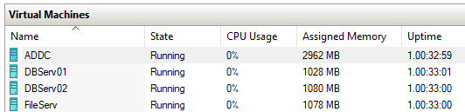

Step 1: Enable Always On in all participating instances of SQL Server
- Open SQL Server Configuration Manager (as Administrator).
- Select SQL Server Services.
- Right Click on the instance of SQL server and select Properties.
- In the properties form, select Always On Availability Groups tab.
- Tick Enable Always On Availability Groups.
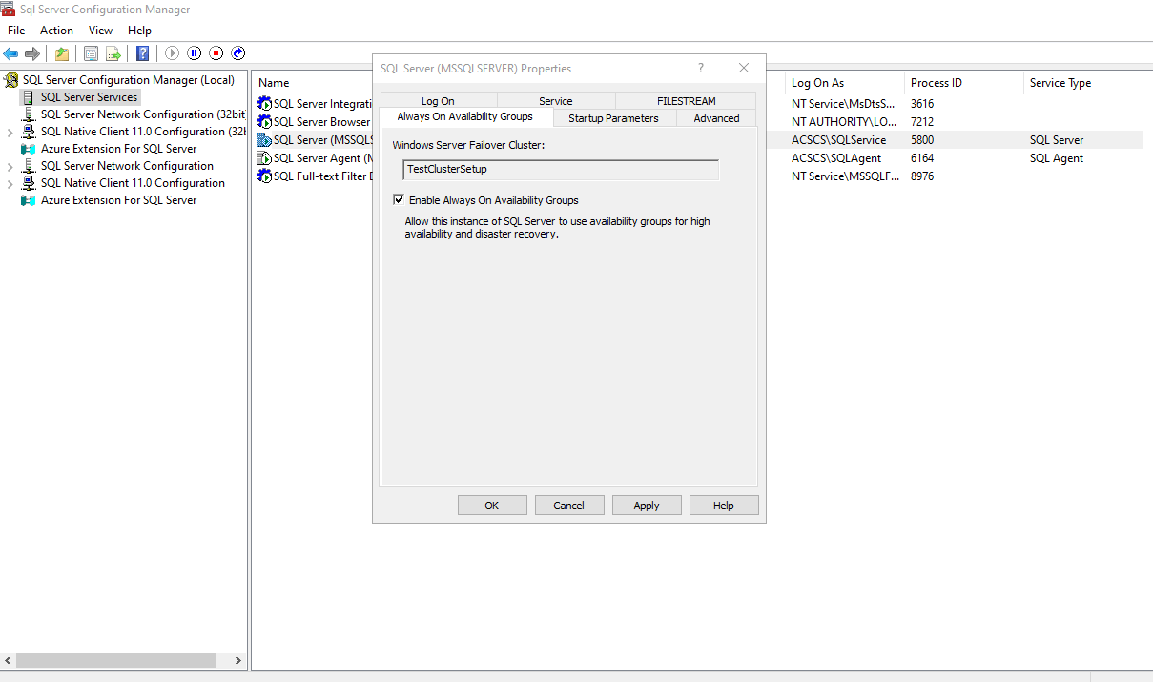
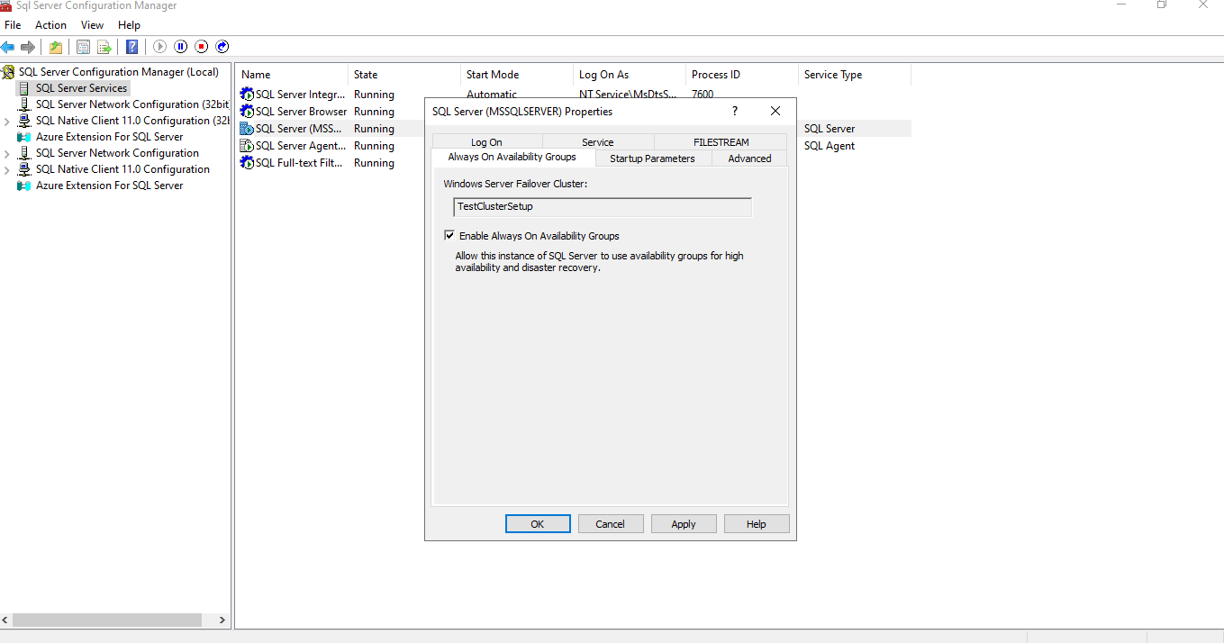
- A popup notification will appear to state that the changes will be applied but will only take effect after the service is restarted. Click on OK.
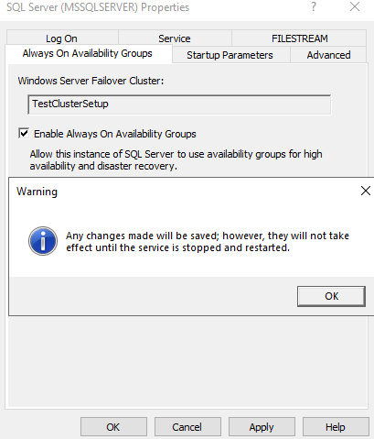

Step 2: Restart SQL Server instance Service
Right Click on the SQL Server instance and select Restart. The Stopping and starting pane will briefly appear
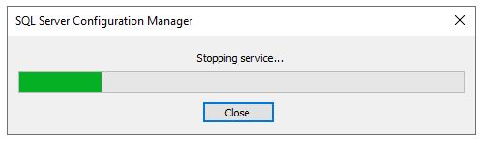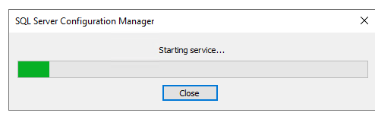

Step 3: Configure AG per database per node
To create a basic availability group, use the CREATE AVAILABILITY GROUP Transact-SQL command and specify the WITH BASIC option (the default is ADVANCED). You can also create the basic availability group using the UI in SQL Server Management Studio.
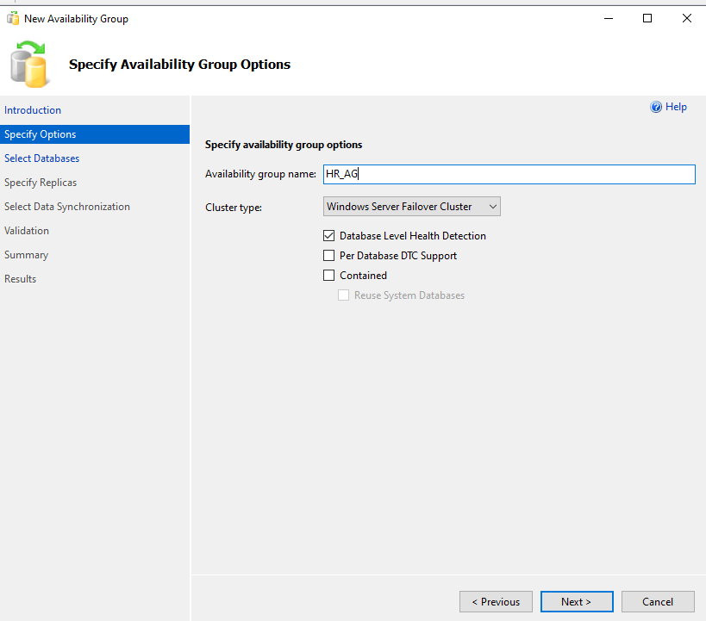
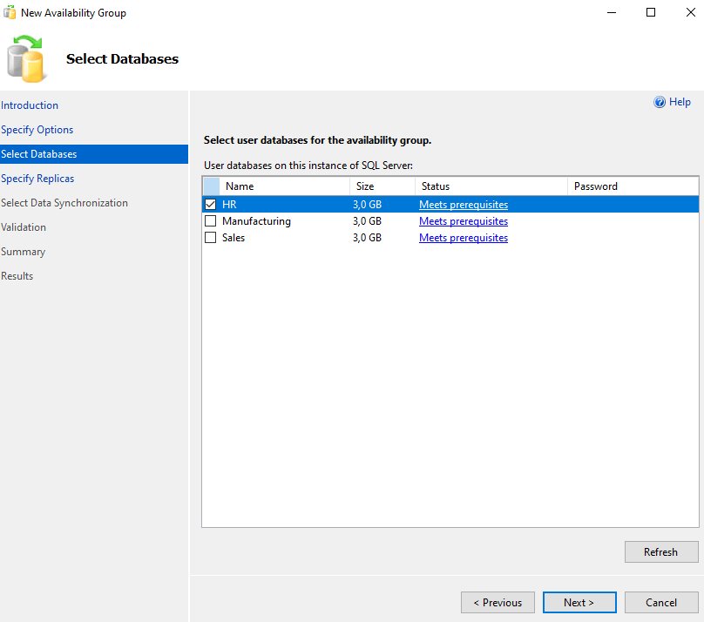
For the HR database, we opt for Asynchronous Secondary:
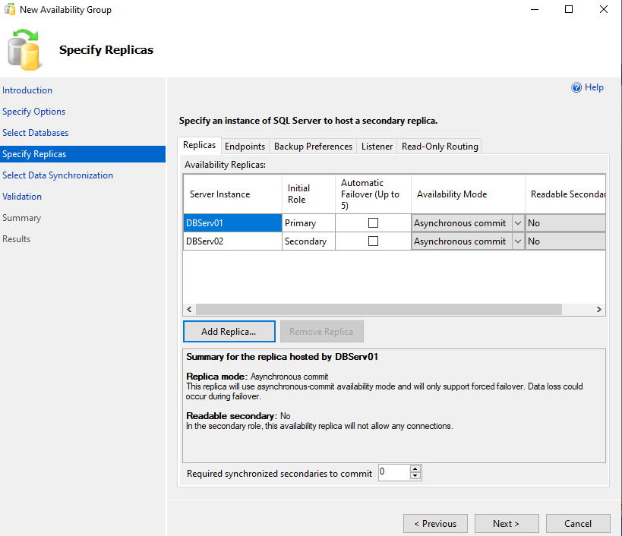
Endpoints:
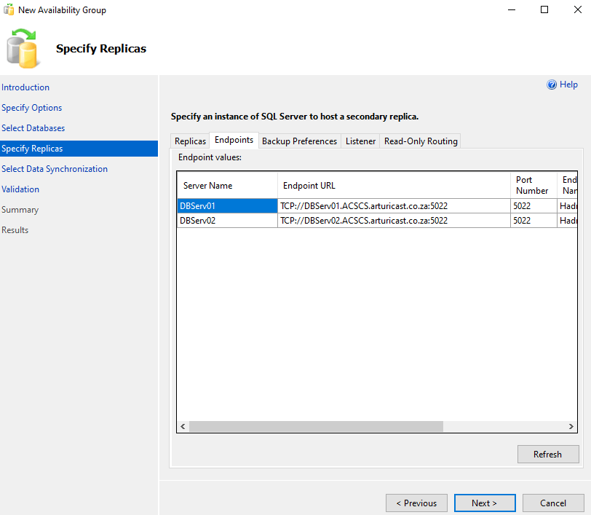
Backup Preference:
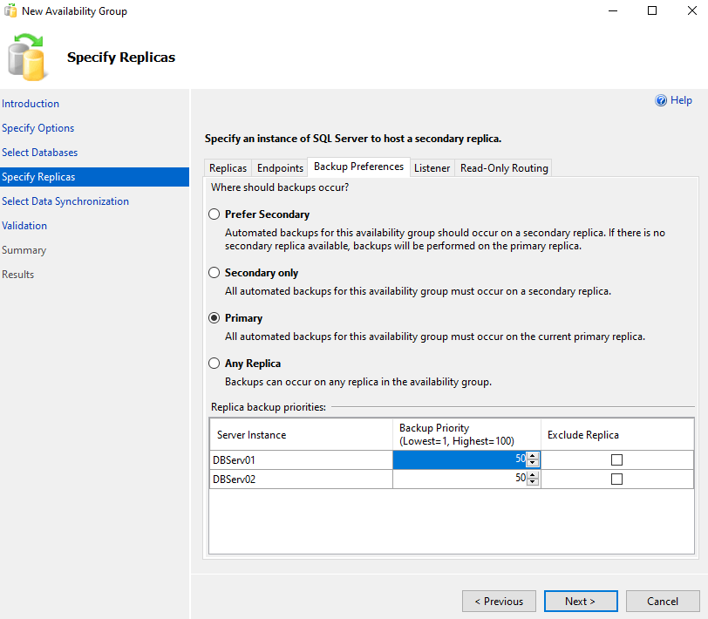
Listener:
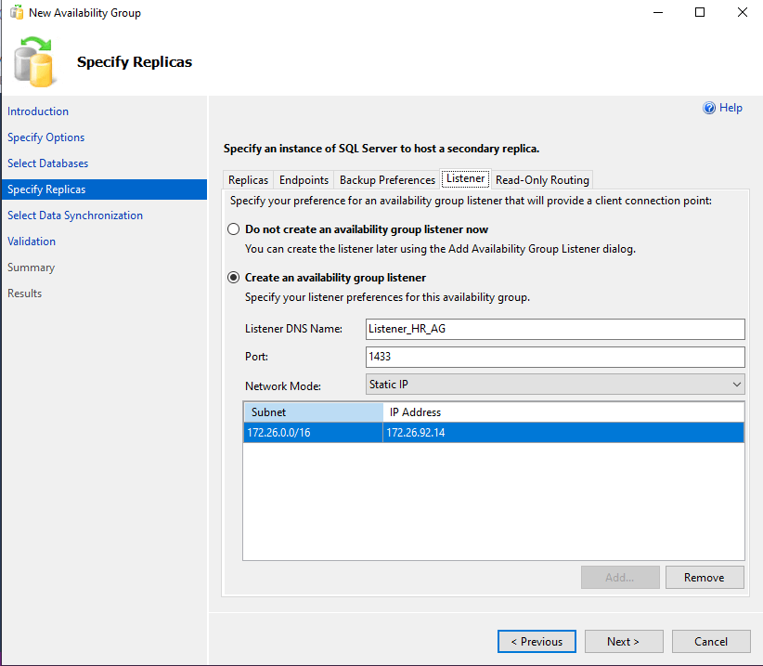
Once that is done, we proceed to Data Synchronisation:
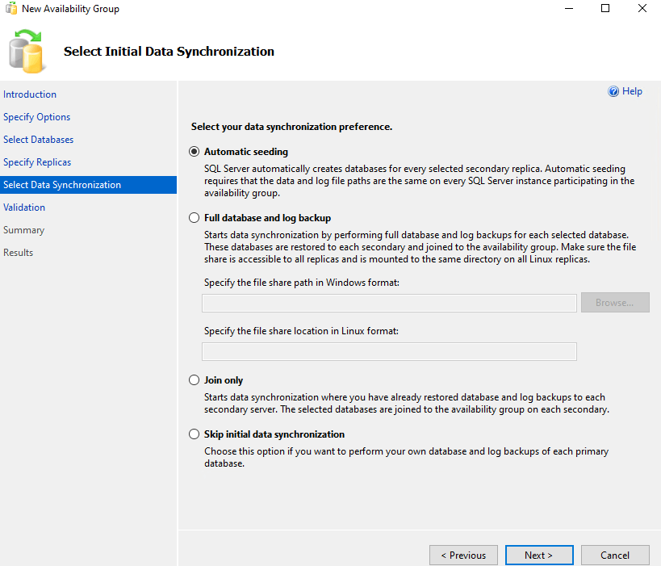
We are going with Join only, as a backup and restore was done on the secondary. This will take us to the validation page:
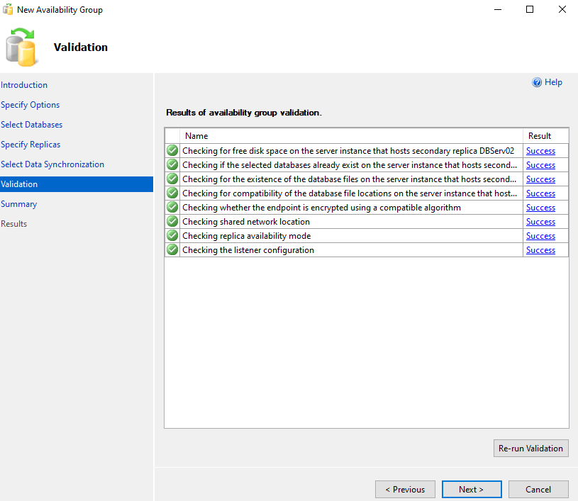
Summary:
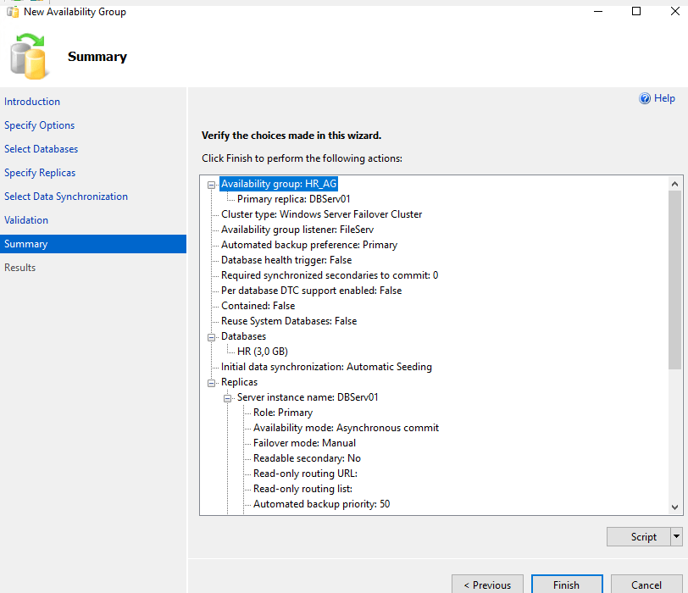
Pressing Finish will execute setup at the various locations.
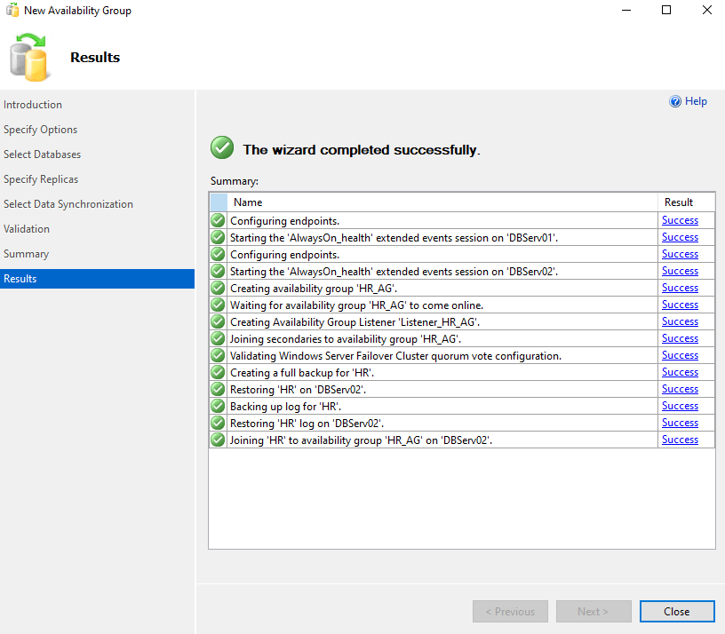
The full detail of what was done is reflected.
Now, looking at the primary DB server in SSMS, we can see:
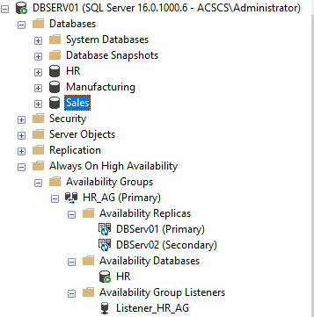
The Secondary Replica reflects:
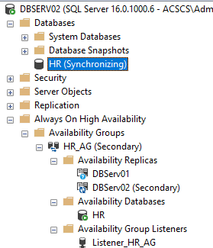
We can check that the Virtual Network Node for the listener has been created in the domain:
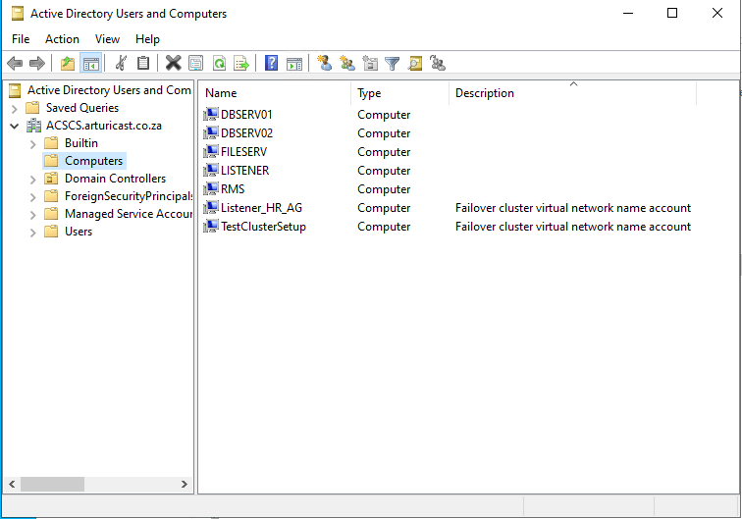

Step 4: Adding more databases to AG
Adding the other databases to availability groups reflects as follows:
- On the primary replica:
  - In SSMS Connected database list:
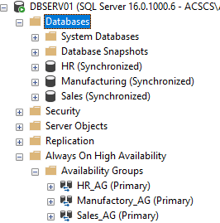
  - AG Dashboard:
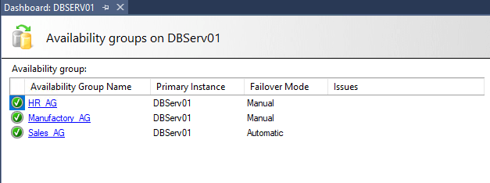
- On the secondary replica:
  - In SSMS Connected database list:
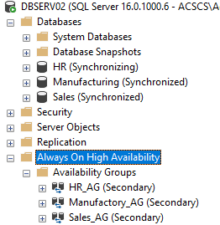
  - AD Dashboard:
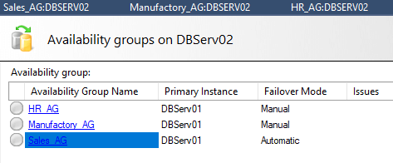
- On Active Directory:
  - Computers:
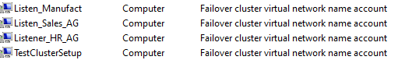

The beauty of BADR
Connections to the database can now be made using the listener, and not directly to the primary and/or secondary replica’s (even though an instance of SQL server had not been installed on the listener (which is, in and of itself, a virtual network node, with no OS or applications installed)). Thus, in the case of a failover, it is not necessary to change the connection string in the application.
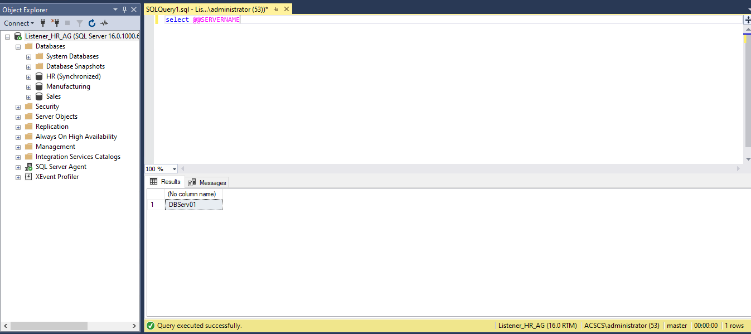
The Always-On Dashboard gives a birds-eye view of the synchronisation status of participating databases
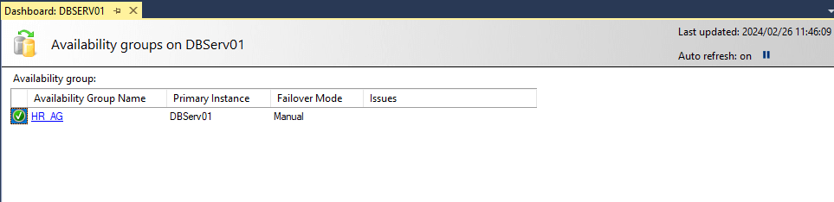
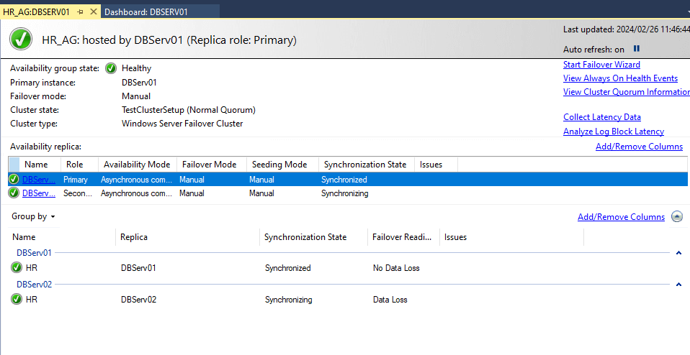
Manual Failover can take place with the click of a button.
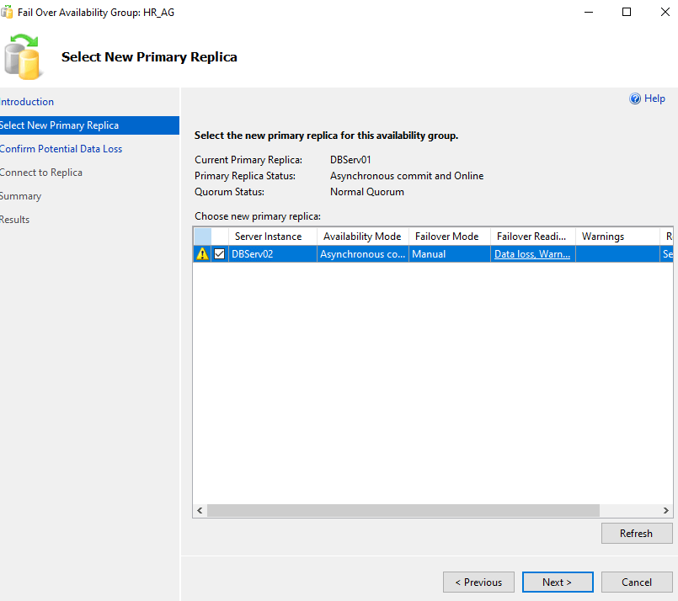
Here is the entire script applied, at each server as highlighted, to activate BADR:
--- YOU MUST EXECUTE THE FOLLOWING SCRIPT IN SQLCMD MODE.

:Connect DBSERV01

IF (SELECT state FROM sys.endpoints WHERE name = N'Hadr_endpoint') <> 0
BEGIN
ALTER ENDPOINT [Hadr_endpoint] STATE = STARTED
END
GO
use [master]
GO
GRANT CONNECT ON ENDPOINT::[Hadr_endpoint] TO [MyDomain\SQLService]
GO

:Connect DBSERV01

IF EXISTS(SELECT * FROM sys.server_event_sessions WHERE name='AlwaysOn_health')
BEGIN
ALTER EVENT SESSION [AlwaysOn_health] ON SERVER WITH (STARTUP_STATE=ON);
END

IF NOT EXISTS(SELECT * FROM sys.dm_xe_sessions WHERE name='AlwaysOn_health')
BEGIN
ALTER EVENT SESSION [AlwaysOn_health] ON SERVER STATE=START;
END
GO

:Connect DBSERV02

IF (SELECT state FROM sys.endpoints WHERE name = N'Hadr_endpoint') <> 0
BEGIN
ALTER ENDPOINT [Hadr_endpoint] STATE = STARTED
END
GO
use [master]
GO
GRANT CONNECT ON ENDPOINT::[Hadr_endpoint] TO [MyDomain\SQLService]
GO

:Connect DBSERV02

IF EXISTS(SELECT * FROM sys.server_event_sessions WHERE name='AlwaysOn_health')
BEGIN
ALTER EVENT SESSION [AlwaysOn_health] ON SERVER WITH (STARTUP_STATE=ON);
END
IF NOT EXISTS(SELECT * FROM sys.dm_xe_sessions WHERE name='AlwaysOn_health')
BEGIN
ALTER EVENT SESSION [AlwaysOn_health] ON SERVER STATE=START;
END
GO

:Connect DBSERV01

USE [master]
GO
CREATE AVAILABILITY GROUP [HR_AG]
WITH (AUTOMATED_BACKUP_PREFERENCE = PRIMARY,
BASIC,
DB_FAILOVER = ON,
DTC_SUPPORT = NONE,
REQUIRED_SYNCHRONIZED_SECONDARIES_TO_COMMIT = 0)
FOR DATABASE
REPLICA ON N'DBServ01' WITH (ENDPOINT_URL = N'TCP://DBServ01.ACSCS.arturicast.co.za:5022', FAILOVER_MODE = MANUAL, AVAILABILITY_MODE = ASYNCHRONOUS_COMMIT, BACKUP_PRIORITY = 50, SEEDING_MODE = MANUAL, SECONDARY_ROLE(ALLOW_CONNECTIONS = NO)),
N'DBServ02' WITH (ENDPOINT_URL = N'TCP://DBServ02.ACSCS.arturicast.co.za:5022', FAILOVER_MODE = MANUAL, AVAILABILITY_MODE = ASYNCHRONOUS_COMMIT, BACKUP_PRIORITY = 50, SEEDING_MODE = MANUAL, SECONDARY_ROLE(ALLOW_CONNECTIONS = NO));
GO

:Connect DBSERV01

USE [master]
GO
ALTER AVAILABILITY GROUP [HR_AG]
ADD LISTENER N'Listener_HR_AG' (
WITH IP
((N'172.26.92.14', N'255.255.0.0')
)
, PORT=1433);
GO

:Connect DBSERV02

ALTER AVAILABILITY GROUP [HR_AG] JOIN;
GO

:Connect DBSERV01

BACKUP DATABASE TO DISK = N'\\DBSERV01\UserDB\HR\HR.bak' WITH COPY_ONLY, FORMAT, INIT, SKIP, REWIND, NOUNLOAD, COMPRESSION, STATS = 5

GO

:Connect DBSERV02

RESTORE DATABASE FROM DISK = N'\\DBSERV01\UserDB\HR\HR.bak' WITH NORECOVERY, NOUNLOAD, STATS = 5
GO

:Connect DBSERV01

BACKUP LOG TO DISK = N'\\DBSERV01\UserDB\HR\HR.trn' WITH NOFORMAT, INIT, NOSKIP, REWIND, NOUNLOAD, COMPRESSION, STATS = 5
GO

:Connect DBSERV02

RESTORE LOG FROM DISK = N'\\DBSERV01\UserDB\HR\HR.trn' WITH NORECOVERY, NOUNLOAD, STATS = 5
GO

:Connect DBSERV02

-- Wait for the replica to start communicating
begin try

declare @conn bit
declare @count int
declare @replica_id uniqueidentifier
declare @group_id uniqueidentifier

set @conn = 0
set @count = 30 -- wait for 5 minutes

if (serverproperty('IsHadrEnabled') = 1)
and (isnull((select member_state from master.sys.dm_hadr_cluster_members where upper(member_name COLLATE Latin1_General_CI_AS) = upper(cast(serverproperty('ComputerNamePhysicalNetBIOS') as nvarchar(256)) COLLATE Latin1_General_CI_AS)), 0) <> 0)
and (isnull((select state from master.sys.database_mirroring_endpoints), 1) = 0)
begin
select @group_id = ags.group_id from master.sys.availability_groups as ags where name = N'HR_AG'
select @replica_id = replicas.replica_id from master.sys.availability_replicas as replicas where upper(replicas.replica_server_name COLLATE Latin1_General_CI_AS) = upper(@@SERVERNAME COLLATE Latin1_General_CI_AS) and group_id = @group_id

while @conn <> 1 and @count > 0
begin
set @conn = isnull((select connected_state from master.sys.dm_hadr_availability_replica_states as states where states.replica_id = @replica_id), 1)
if @conn = 1
begin
-- exit loop when the replica is connected, or if the query cannot find the replica status
break
end

waitfor delay '00:00:10'

set @count = @count - 1
end
end

end try
begin catch
-- If the wait loop fails, do not stop execution of the alter database statement
end catch

ALTER DATABASE SET HADR AVAILABILITY GROUP = [HR_AG];
GO
GO

Always ON Healthcheck Report

-----------GetAlwaysOnStatus.sql
if (SERVERPROPERTY('ishadrenabled') = 1)
Begin
select convert(Nvarchar(500),SERVERPROPERTY('servername')) as Servername, n.group_name AlwaysONGroup,n.replica_server_name,n.node_name NodeName,rs.role_desc Role,
db_name(drs.database_id) as 'DBName',drs.synchronization_state_desc State,drs.synchronization_health_desc Health
,getdate() as Rundate
from master.sys.dm_hadr_availability_replica_cluster_nodes n
join master.sys.dm_hadr_availability_replica_cluster_states cs
on n.replica_server_name = cs.replica_server_name
join master.sys.dm_hadr_availability_replica_states rs
on rs.replica_id = cs.replica_id
join master.sys.dm_hadr_database_replica_states drs
on rs.replica_id=drs.replica_id
join master.sys.availability_group_listeners AS AGL ON AGL.group_id = rs.group_id
where n.replica_server_name = @@SERVERNAME
and rs.replica_id=drs.replica_id
End
-------------TruncateTable
Truncate table dbadmin.dbo.DbadminDashboard_alwayson_status
--------------GetServerList
--Query to check All prod servers
--select SRV.server_name from [ServerName].[msdb].[dbo].
--[sysmanagement_shared_registered_servers_internal] SRV join
--[ServerName].[msdb].[dbo].[sysmanagement_shared_server_groups_internal] GRP
--on SRV.server_group_id=GRP.server_group_id
--where substring(SRV.server_name,4,4) = 'PROD'
--and substring(SRV.server_name,1,3) in
--( )
--Union
--select SRV.server_name from [ServerName].[msdb].[dbo].
--[sysmanagement_shared_registered_servers_internal] SRV join
--[ServerName].[msdb].[dbo].[sysmanagement_shared_server_groups_internal] GRP
--on SRV.server_group_id=GRP.server_group_id
--and GRP.name = 'XXX'
--order by SRV.server_name asc
--Query to check All Non-prod servers
select SRV.server_name from [ServerName].[msdb].[dbo].
[sysmanagement_shared_registered_servers_internal] SRV join
[ServerName].[msdb].[dbo].[sysmanagement_shared_server_groups_internal] GRP
on SRV.server_group_id=GRP.server_group_id
where substring(SRV.server_name,4,4) = 'PROD'

--Union
--select SRV.server_name from [ServerName].[msdb].[dbo].
--[sysmanagement_shared_registered_servers_internal] SRV join
--[ServerName].[msdb].[dbo].[sysmanagement_shared_server_groups_internal] GRP
--on SRV.server_group_id=GRP.server_group_id

--Query to check All servers
--select SRV.server_name from [ServerName].[msdb].[dbo].
--[sysmanagement_shared_registered_servers_internal] SRV join
--[ServerName].[msdb].[dbo].[sysmanagement_shared_server_groups_internal] GRP
--on SRV.server_group_id=GRP.server_group_id
--where substring(SRV.server_name,1,3) in
--()
--order by SRV.server_name asc

-------------MainPS.ps1
$cmsserver ='ServerName'
$cmsdb = 'dbadmin'
$defaultdb='Master'
$uname ='XXXXXX'
$pword = 'XXXXXXX'
# change this parameter if running for other things
$BaseDir='C:SQLServerReportMonitoringAlwaysOn'
$Outpath = $BaseDir + "Output"
$LogFile = $BaseDir + 'LogFile.txt'
$FailedServers = $BaseDir + 'FailedServers.txt'
#$SuccessServers = $BaseDir + 'SuccessServers.txt'
"CMS Server -- " + $cmsserver | out-file $LogFile -Width 180
"Output Directory --" + $Outpath | out-file $LogFile -Width 180 -Append
"Base Directory --" + $BaseDir | out-file $LogFile -Width 180 -Append
"Logfile --" + $LogFile | out-file $LogFile -Width 180 -Append
"This file captures servers which are not reachable or have some issues.Please check them." + "`r`n" + "For detailed status,query table -- dbadmin.dbo.DbadminDashboard_alwayson_status " + "`r`n" | out-file $FailedServers -Width 180

$SuccessServers = $BaseDir + 'SuccessServers.txt'
"This file captures servers which are reached successfully." + "`r`n" + "For detailed status,query table -- dbadmin.dbo.DbadminDashboard_SqlServices_Status " + "`r`n" | out-file $SuccessServers -Width 180

"SQL Server Processing - Started " | out-file $LogFile -Width 180 -Append
Get-ChildItem -Path $Outpath *.csv | out-file $LogFile -Width 180 -Append

"removing old files starts" | out-file $LogFile -Width 180 -Append
Get-ChildItem -Path $Outpath *.csv | foreach { Remove-Item $_.FullName}
"removing old files done" | out-file $LogFile -Width 180 -Append

$CurDate = (Get-Date -Format MM) + (get-Date -format dd) + (get-Date -format yyyy)
$CurDatetime = (Get-Date -Format MM) + (get-Date -format dd) + (get-Date -format yyyy) + (get-Date -format hh) + (get-Date -format mm)
$ServerNameFile= $BaseDir + "GetServerList.sql"
$GetQueryFile =$BaseDir + "GetAlwaysOnStatus.sql"
$ServerNameQuery = get-content "$ServerNameFile"
'ServerQuery -- ' + $ServerNameQuery + "`r`n" | out-file $LogFile -Width 180 -Append
$serverlist = Invoke-Sqlcmd -ServerInstance $cmsserver -Database $cmsdb -Inputfile $ServerNameFile -QueryTimeout 300
$FailedServers = $BaseDir + 'FailedServers.txt'
ForEach ($instance in $serverlist)
{
$instance=$instance.Item(0)
$servername = $instance.split("") |Select-Object -Index 0
"`r`n" + 'Checking Server --' + $servername | out-file $LogFile -Width 180 -Append
If (Test-Connection -ComputerName $servername -quiet -BufferSize 32 -Count 1 )
{
#move to fetch the data if ping succeeds
$servername + ' --Ping Succeeded' | out-file $LogFile -Width 180 -Append
try
{
#log start of process
# $instance= $instance + ",1433"
#"$Instance fetch starts at " + $CurDatetime | out-file $LogFile -Width 180 -Append
$results=Invoke-Sqlcmd -ServerInstance $instance -Database $defaultdb -Username $uname -Password $pword -InputFile $GetQueryFile -QueryTimeout 300
"Saving Success Backup Results in CSV format..." + $instance
$CsvFilePath = $Outpath + "AlwaysONStatus_Report.csv"
$results | export-csv $CsvFilePath -NoTypeInformation -Append
#log end of process
"$Instance --DataExtract Succeeded at " + $CurDatetime | out-file $LogFile -Width 180 -Append
"$Instance --Succeeded "| out-file $SuccessServers -Width 180 -Append
}

{
"$Instance --DataExtract Failed at " + $CurDatetime | out-file $FailedServers -Width 180 -Append
}
}
#Catch the error if the ping test fails
else
{
$servername + ' --Ping Failed ' | out-file $FailedServers -Width 180 -Append
}
}

(Get-Content $csvFilePath) | Foreach-Object {$_ -replace "`"", ""} | Set-Content $CsvFilePath
"SQL Server Processing - COMPLETED" +"`r`n" | out-file $LogFile -Width 180 -Append

----------------Mail.ps1
"Generating mail "
$BaseDir='D:PSScriptAlwaysOn'
$CsvFilePath='D:PSScriptAlwaysOnOutput*.csv'
$smtp='XXXXXXXXXXXXXXX'
$ToAddress='XXXXXXXXXXX'
$fromAddress='XXXXXXXXXXX'
$EmailSubject = "Dashboard_alwayson_final_status Reports" + " - " +'-' + $CurDate
$Body = "`r`n" + "`r`n" + "Dashboard_alwayson_final_status Reports --"
$files = get-childitem $CsvFilePath | where name -like "*.csv"
$attachments = $files.fullname
Send-MailMessage -to $ToAddress -From $fromAddress -SmtpServer $smtp -Subject $EmailSubject -BodyAsHtml $body -Attachments $attachments
"Mail sent"
"Dashboard_alwayson_final_status Reports "
----------------CsvToTable.ps1
'table DbadminDashboard_alwayson_final_status truncation start'
#load data in table
$BaseDir='C:SQLServerReportMonitoringAlwaysOn'
$CsvFilePath=$BaseDir + 'Output*.csv'
$cmsserver ='CMSServerName'
$cmsdb = 'dbadmin'
$table = 'dbo.DbadminDashboard_alwayson_status'
$TruncateFile= $BaseDir + "TruncateTable.sql"
$results=Invoke-Sqlcmd -ServerInstance $cmsserver -Database $cmsdb -InputFile $TruncateFile -QueryTimeout 300
'table DbadminDashboard_alwayson_final_status truncation end'
'table DbadminDashboard_alwayson_final_status load start'
'table DbadminDashboard_alwayson_final_status load start'
$CSVImport = Import-CSV $CsvFilePath
ForEach ($CSVLine in $CSVImport)
{
$CSVServername = $CSVLine.Servername
$CSVgroup_name = $CSVLine.AlwaysONGroup
$CSVreplica_server_name = $CSVLine.replica_server_name
$CSVnode_name = $CSVLine.NodeName
$CSVrole_desc = $CSVLine.Role
$CSVDBName = $CSVLine.DBName
$CSVsynchronization_state_desc = $CSVLine.state
$CSVsynchronization_health_desc = $CSVLine.health

$SQLInsert = "USE $cmsdb
INSERT INTO $table (Servername,group_name,replica_server_name,node_name,role_desc,DBName,synchronization_state_desc,synchronization_health_desc) VALUES('$CSVServername','$CSVgroup_name', '$CSVreplica_server_name', '$CSVnode_name', '$CSVrole_desc', '$CSVDBName', '$CSVsynchronization_state_desc','$CSVsynchronization_health_desc')"
Invoke-SQLCmd -ServerInstance $cmsserver -Database $cmsdb -Query $SQLInsert
}

'table DbadminDashboard_alwayson_final_status load end'

AlwaysON health check alerts

SELECT AGS.name AS AGGroupName, AR.replica_server_name AS InstanceName,
HARS.role_desc, sd.name AS DBName,DRS.database_id, AR.availability_mode_desc AS SyncMode,
DRS.synchronization_state_desc AS SyncState,DRS.last_hardened_lsn,DRS.end_of_log_lsn,
DRS.last_redone_lsn,
DRS.last_hardened_time, -- On a secondary database, time of the log-block identifier for the last hardened LSN (last_hardened_lsn).
DRS.last_redone_time, -- Time when the last log record was redone on the secondary database.
DRS.log_send_queue_size,DRS.redo_queue_size,
--Time corresponding to the last commit record.
--On the secondary database, this time is the same as on the primary database.
--On the primary replica, each secondary database row displays the time that the secondary replica that hosts that secondary database
-- has reported back to the primary replica. The difference in time between the primary-database row and a given secondary-database
-- row represents approximately the recovery time objective (RPO), assuming that the redo process is caught up and that the progress
-- has been reported back to the primary replica by the secondary replica.
DRS.last_commit_time
into ##HA_stats
FROM master.sys.dm_hadr_database_replica_states DRS
LEFT JOIN master.sys.availability_replicas AR
ON DRS.replica_id = AR.replica_id
LEFT JOIN master.sys.availability_groups AGS
ON AR.group_id = AGS.group_id
LEFT JOIN master.sys.dm_hadr_availability_replica_states HARS ON AR.group_id = HARS.group_id
AND AR.replica_id = HARS.replica_id
INNER JOIN master.sys.databases sd on DRS.database_id = sd.database_id

--Alert if not in SYNCHRONIZED status:
if exists (select * from ##HA_stats where SyncState not like ''SYNCHRONIZED'')
begin
EXEC msdb..sp_send_dbmail
@recipients=''XXXX@gmail.com'',

@subject = ''Always ON: Issue with Non- prod AlwaysOn Server -ServerName'',
@body = ''The following records are dbs that are not currently in a SYNCHRONIZED status. An automated attempt is being made to resume the data transfer. ',
@query = ''select cast(InstanceName as varchar(20)) InstanceName, cast(role_desc as varchar(10)) role_desc, cast(DBName as varchar(15)) DBName, cast(SyncState as varchar(20)) SyncState from ##HA_stats where SyncState not like ''''SYNCHRONIZED''''''

--attempt to resume node
---ALTER DATABASE CKOLTP SET HADR RESUME
end

if exists (select * from sys.databases where state_desc!=''ONLINE'')
begin
DECLARE @TEXT AS VARCHAR(300)

select getdate() as State_Date_Time,name AS Database_Name,state_desc AS DB_Status into ##Current_DB_State from sys.databases where state_desc!=''ONLINE''
insert into master.dbo.DB_Status_History select * from ##Current_DB_State

SELECT @TEXT=''Secondary Server :ServerName.''+CHAR(13)+''The Following Database is not ONLINE nor in Synchronized State. Please check and assist.''+CHAR(13)

EXEC msdb..sp_send_dbmail
@recipients=''XXXX@gmail.com'',

@subject = ''Always ON : Issue with Non- prod database not Online. ServerName '',
@body = @TEXT,
@query = ''select * from ##Current_DB_State''

--attempt to resume node
---ALTER DATABASE CKOLTP SET HADR RESUME

end
--Write to history
insert into master..AGHistory, select getdate(), * from ##HA_stats

